Authorized Negotiator/Contract Administrator Updates
Version 1.0

This document will explain the Authorized Negotiators/Contract Administrators enhancements that will be available in the November 2012 Release.

2012
AM System Support
8/7/2012

Table of Contents
1 Background 1
2 Accessing the eOffer/eMod application 2
Digital Certificates 2
Accessing eOffer/eMod 3
• Scenario 1 - The Happy Path (everything happens as expected) 3
• Scenario 2 - Never listed as a negotiator 3
• Scenario 3 - A change happened 3
3 Six Validations and matching data 3
Validation 1 - Last Name + Email Match found 4
Validation 2 - First Name + Email Match found 5
Validation 3 - Only Email Match found 6
Validation 4 - Last Name + First Name Match found 7
Validation 5 - ONLY Last Name Match found 8
Validation 6 - ONLY First Name Match found 9
4 Six Validations and No Matches found 10
Collect Negotiators/Contract Administrators Data 10
No Contract Administrators found 11
Contract Administrators found 11
5 Approve/Reject Request 12
One of the Authorized Negotiators/Contract Administrators logs into eMod 12
Authorized Negotiators/Contract Administrators Accept/Approve the request 12
Authorized Negotiator/Contract Administrator Rejects/Denies the request 13
6 When the request is pending 14
Requestor trying to select the contract (after 7 days) 14
Requestor trying to select the contract (before 7 days) 14

Background
The Authorized Negotiator process is being enhanced to assist vendors and COs/CSs to update the negotiator information faster. When a vendor accesses the eOffer application and needs to be added as an Authorized Negotiator/Contract Administrator, they will be able to submit a request to the existing Authorized Negotiator/Contract Administrator on the contract or if no Authorized Negotiator/Contract Administrators are listed on the contract, it will submit the request directly to the CO/CS.

In this process, the Authorized Negotiator/Contract Administrator details will be captured from their digital certificate. This includes their first name, last name, middle initial, and email address, which is the current validation that is being checked upon login into the eOffer/eMod application. If any of this data does not match the digital certificate exactly, then the vendor is denied access to the application. In the new process, the certificate details will be captured from the certificate and transferred in the request process to an existing Authorized Negotiator/Contract Administrator or the CO/CS to approve the request. This will eliminate the manual manipulation of the cert information and ensure that when an Authorized Negotiator/Contract Administrator is added they are added correctly the first time.

To facilitate this process we are adding six new validations to the eOffer/eMod digital certificate validation process.

1. Last Name + Email Id match
2. First Name + Email Id match
3. Email Id match
4. Last Name + First Name
5. Last Name
6. First Name

The user will not be able to create or work on any other mod types, until the “Authorized Negotiator” mod type, with the correct data for this logged in user, is submitted and approved.

Vendors will be referred to as Authorized Negotiators prior to contract award and Contract Administrators after contract award.

Accessing the eOffer/eMod application
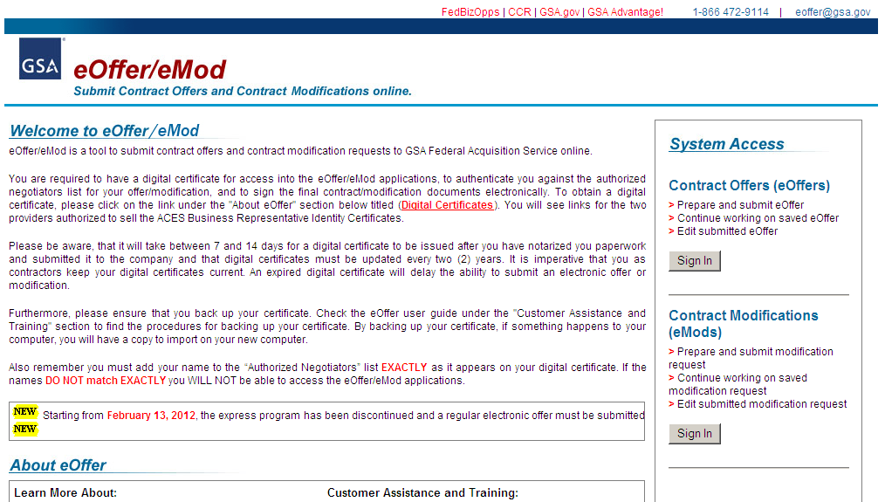
Click Here
Click Here

Digital Certificates

To access the eOffer/eMod application, you are required to have a digital certificate for access into the eOffer/eMod applications, to authenticate you against the Authorized Negotiators list for your offer/modification, and to sign the final offer/modification documents electronically.

To obtain a digital certificate, please click on the link under the "About eOffer" section on the eOffer homepage. You will see links for the two providers authorized to sell the ACES Business Representative Identity Certificates. Please be aware, that it will take between 7 and 14 days for a digital certificate to be issued after you have notarized you paperwork, and submitted it to the company. The digital certificates must be renewed every two (2) years. It is imperative to keep your digital certificates current. An expired digital certificate will delay the ability to submit an electronic offer or modification.

Furthermore, please ensure that you back up your certificate. Check the eOffer user guide under the "Customer Assistance and Training" section to find the procedures for backing up your certificate. By backing up your certificate, if something happens to your computer, you will have a copy to import on your new computer.

Also remember you must add your name to the “Authorized Negotiators” list EXACTLY as it appears on your digital certificate. If the names DO NOT match EXACTLY you WILL NOT be able to access the eOffer/eMod applications.

Accessing eOffer/eMod

When the vendor accesses the eOffer/eMod application they will fall into one of several scenarios.

Scenario 1 - The Happy Path (everything happens as expected)
The vendor is listed in the Negotiator Table and their cert details match perfectly. They are granted access.

Scenario 2 - Never listed as a negotiator
The vendor has never been listed as a negotiator because the original offer was submitted in paper, but the negotiator was not added to the negotiator table; or the old negotiator has left the company and they are trying to get a new negotiator listed in the table.

Scenario 3 - A change happened
The vendor was in the negotiator list and has either changed their name or gotten a new cert and did not list their negotiator details the same way; or the person who initially submitted the vendors information put it in differently than what it was listed as on their digital cert.

When a vendor does not fall into the happy path, the six new validations will run in order to try to find any kind of match.

Six Validations and matching data

When the six new validations are run and a match is found for one of the validations the vendor is able to select their information and submit it to the existing negotiators/Contract Administrators for approval. If the existing negotiators/Contract Administrators do not take an action with 7 days to approve the new addition, the request is then sent to the CO/CS for approval. The vendor’s details are then transferred to the Authorized Negotiators/Contract Administrators or the CO/CS for approval. The CO/CS no longer have to manually input the data, they just review the information received, vet the person in the request to ensure they should be added to the contract if not approved by an existing Authorized Negotiator/Contract Administrator, then award the mod. The Authorized Negotiators/Contract Administrator’s information is added to the contract and granted access within 24 hours. The vendor will see the following screens when one of the six validations is found:

Validation 1 - Last Name + Email Match found
This screen provides the option for the vendor to select his/her name, because the last name plus email id combination is matching, so that a new Authorized Negotiators/Contract Administrator’s mod can be initiated and sent to the existing Authorized Negotiators/Contract Administrators for review and approval.

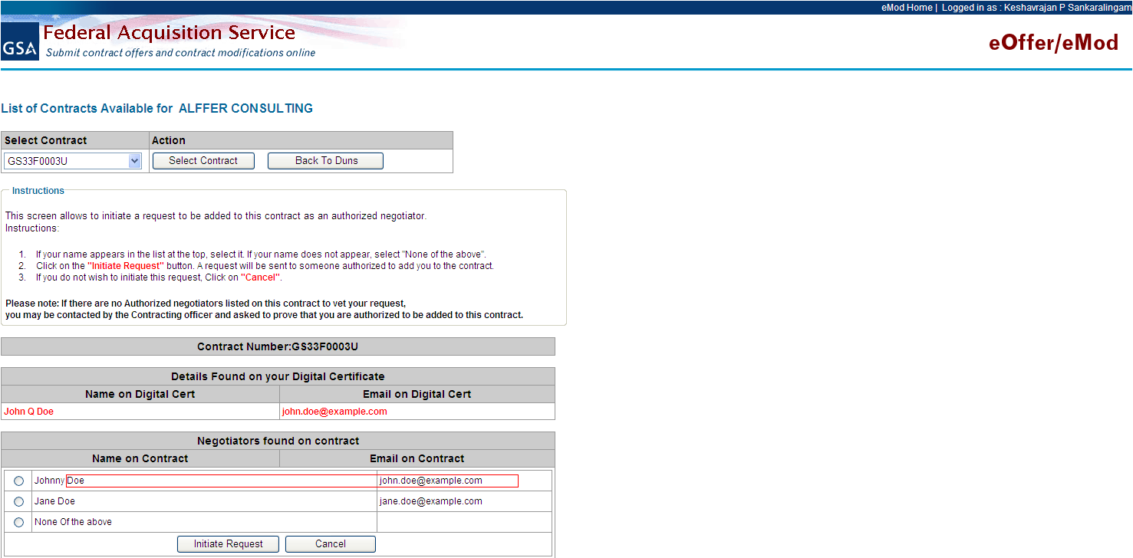

Validation 2 - First Name + Email Match found
This screen provides the option for the vendor to select his/her name, because the first name plus email id combination is matching, so that a new Authorized Negotiators/Contract Administrator’s mod can be initiated and sent to the existing Authorized Negotiators/Contract Administrators for review and approval.

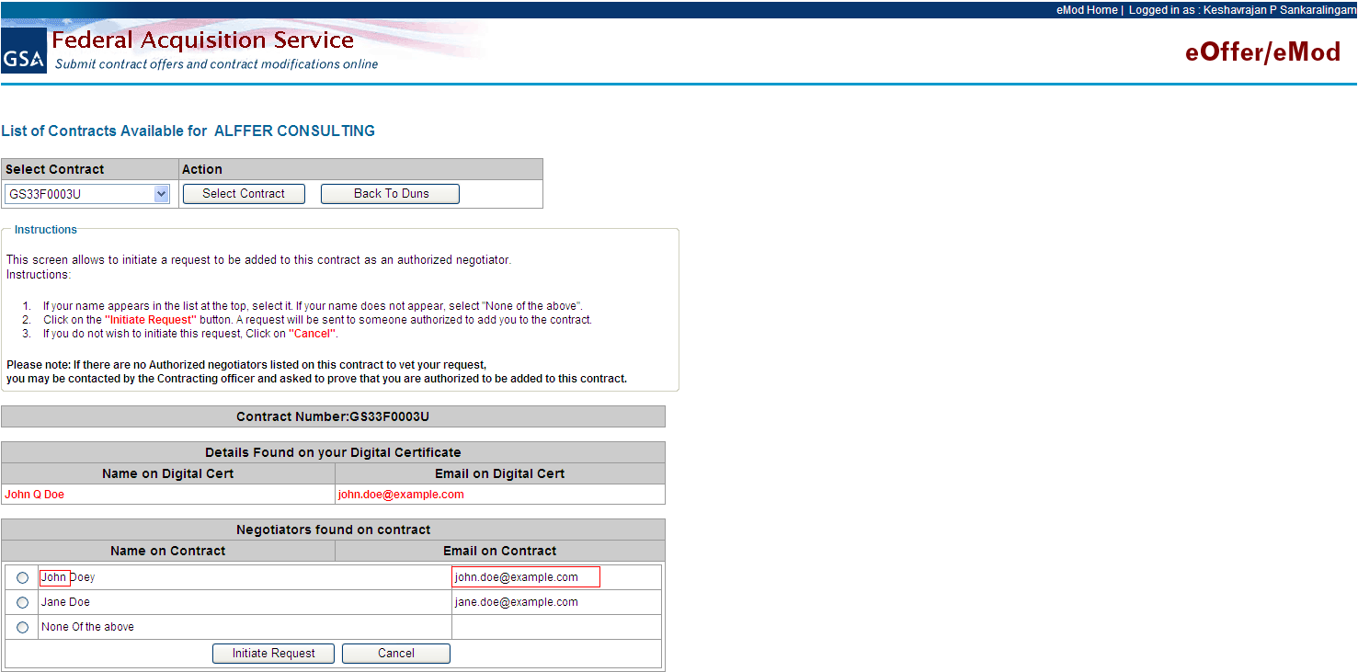

Validation 3 - Only Email Match found
This screen provides the option for the vendor to select his/her name, because ONLY the email is matching, so that a new Authorized Negotiators/Contract Administrator’s mod can be initiated and sent to the existing negotiators/Contract Administrators for review and approval.

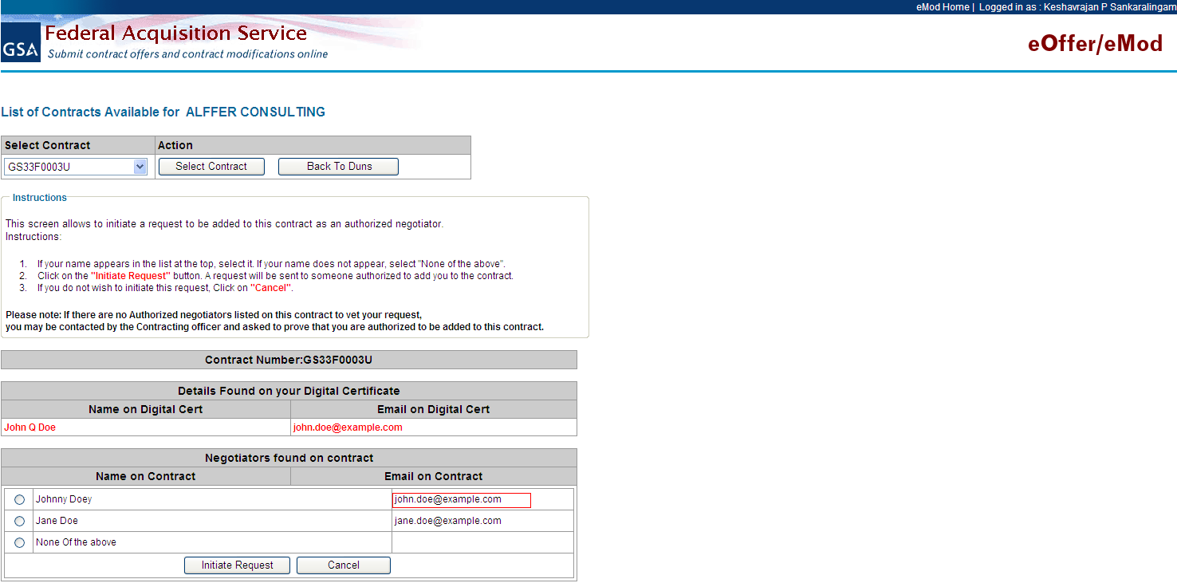

Validation 4 - Last Name + First Name Match found
This screen provides the option for the vendor to select his/her name, because the first name plus last name combination is matching, so that a new Authorized Negotiators/Contract Administrator’s mod can be initiated and sent to the existing Authorized Negotiators/Contract Administrators for review and approval.

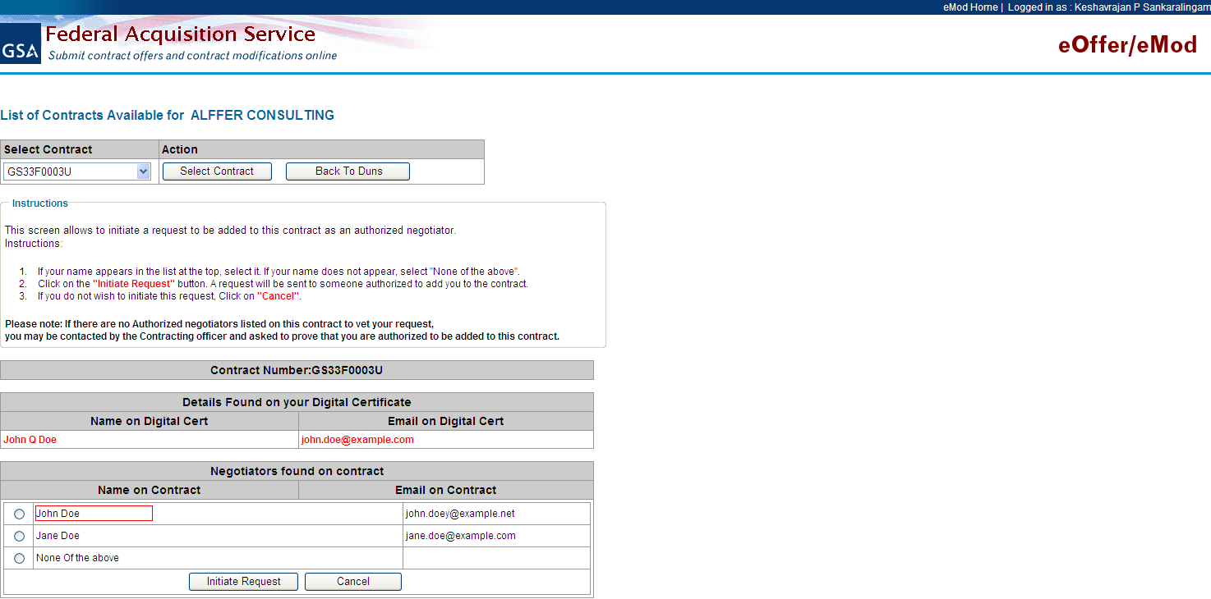

Validation 5 - ONLY Last Name Match found
This screen provides the option for the vendor to select his/her name, because ONLY the last name combination is matching, so that a new Authorized Negotiators/Contract Administrator’s mod can be initiated and sent to the existing Authorized Negotiators/Contract Administrators for review and approval.

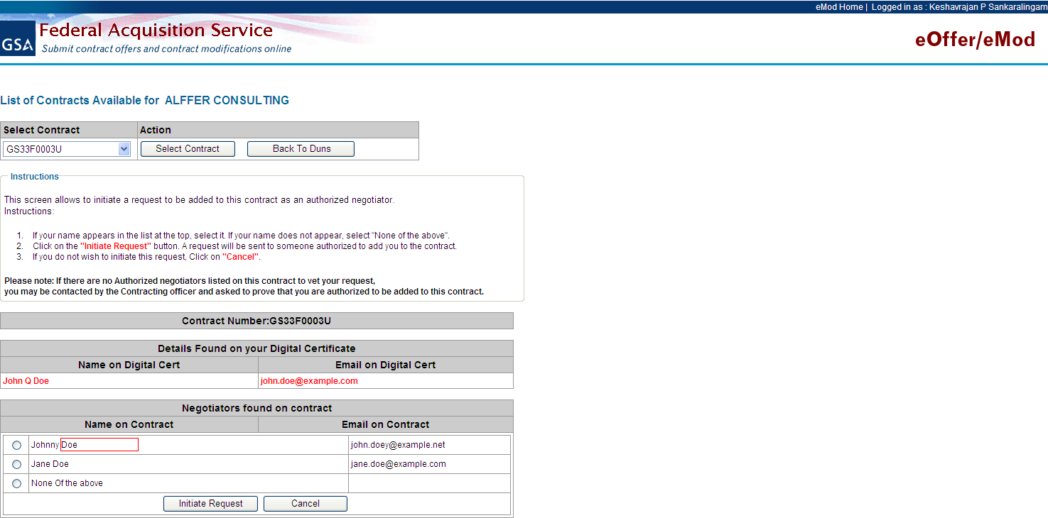

Validation 6 - ONLY First Name Match found
This screen provides the option for the vendor to select his/her name, because ONLY the first name combination is matching, so that a new Authorized Negotiators/Contract Administrator’s mod can be initiated and sent to the existing Authorized Negotiators/Contract Administrators for review and approval.

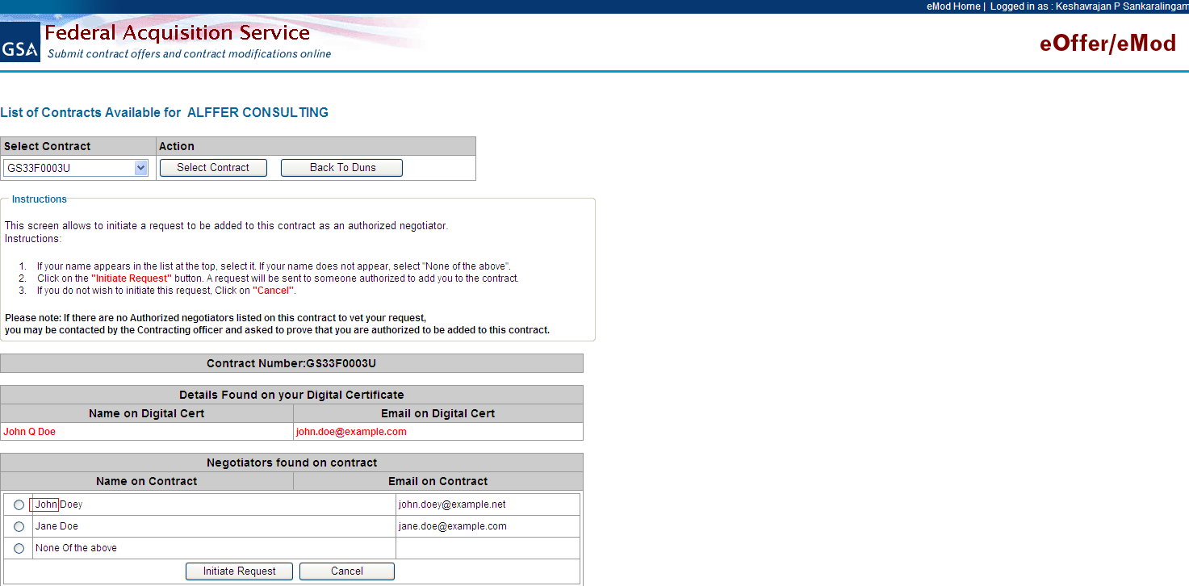

Six Validations and No Matches found

Collect Negotiators/Contract Administrators Data
When there are no matches found and/or there are no Authorized Negotiators/Contract Administrators found in the contract or they are no longer valid, the data of the logged in user will be collected and sent:
- To the CO/CS, if the other negotiators/Contract Administrators didn’t respond in 7 days or if there is no negotiators/Contract Administrators found in the contract.
- To eMod table. This will be used to pre-populate the logged in user’s certificate details, when the other Contract Administrators log into eMod to accept the user’s request to be added as a Contract Administrator; or to FSS Online table to per-populate the data for the CO/CS to approve.

The user will not be able to create or work on any other mod types, until the “Authorized Negotiator/Contract Administrator” mod type, with the correct data for this logged in user, is submitted and approved.

The screen shot below captures the logged in users name and emails from the digital certificate they used to access the application. They will then complete the other required fields and determine if they should be authorized to sign or not. Next, they will submit the request, which will go to the existing Authorized Negotiators/Contract Administrators for approval. If the existing Authorized Negotiators/Contract Administrators do not reply within 7 days, the request is then forwarded to the CO/CS with the Authorized Negotiators/Contract Administrator’s details for review and approval.

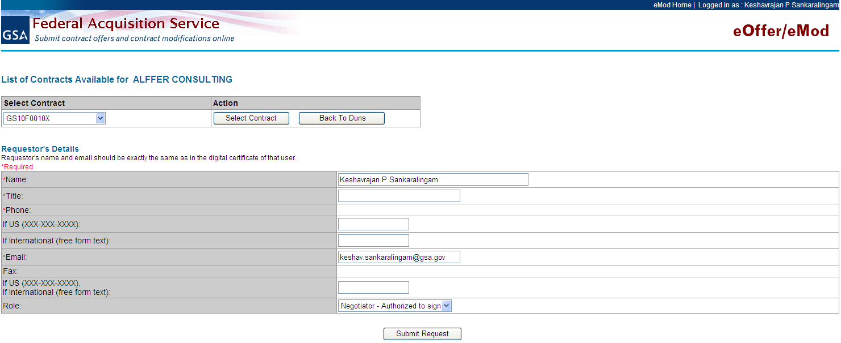

The screen shots below show the messages the vendor will see when they have submitted their details for approval.

No Contract Administrators found
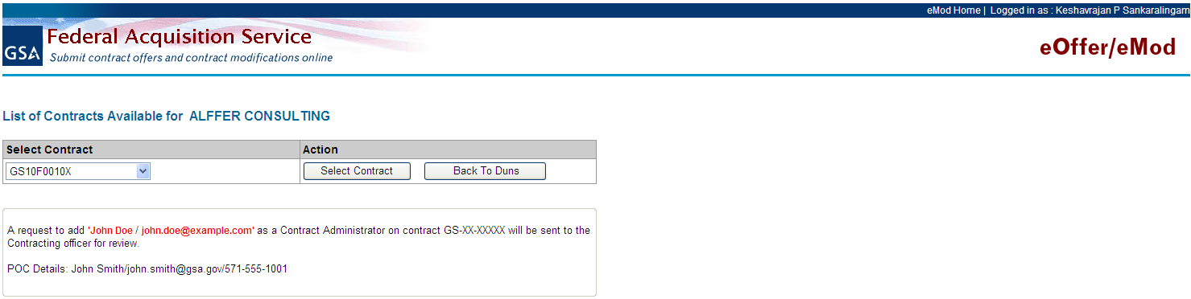

Contract Administrators found

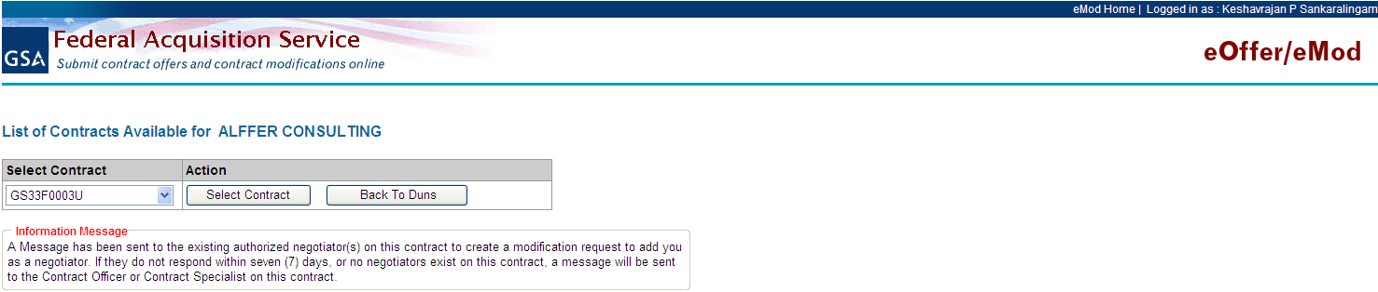

Approve/Reject Request

One of the Authorized Negotiators/Contract Administrators logs into eMod

When the existing Authorized Negotiators/contractor administrators access the eOffer/eMod application to approve/reject the new Authorized Negotiators/Contract Administrators request. They will click “Accept” and continue to the next page.

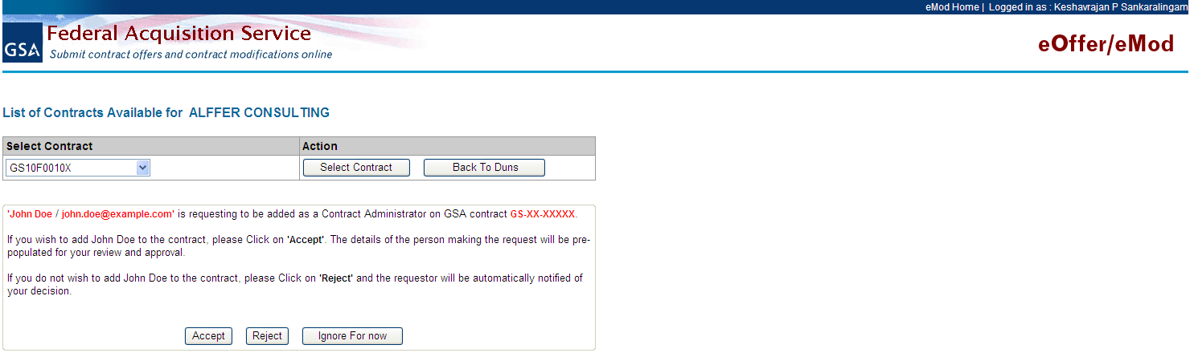

Authorized Negotiators/Contract Administrators Accept/Approve the request
When the Authorized Negotiator approves the request, the system will navigate to the following landing page, where the user will be able to select only the Authorized Negotiator mod type and click submit.

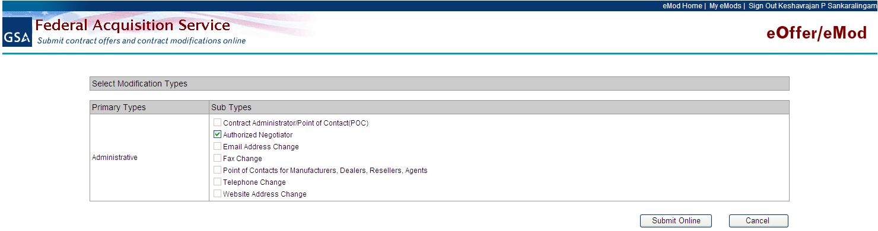

Authorized Negotiator/Contract Administrator Rejects/Denies the request
When the Authorized Negotiator rejects/denies the request, the system will navigate to the following landing page (after the notification is sent to the requestor). Then click “Continue” to proceed.

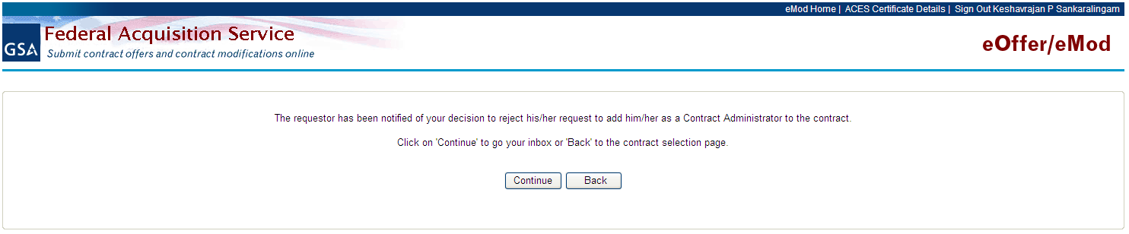

When the request is pending

Requestor trying to select the contract (after 7 days)
When the user logs into eMod and selects the contract, for which
- User is not part of the contract.
- Request for adding the user had already been initiated.
- Request is not accepted / rejected by, other negotiators/Contract Administrators.
- Request initiation happened more than 7 days from current system date.
Or
When there are no Authorized Negotiators/Contract Administrators in the contract.
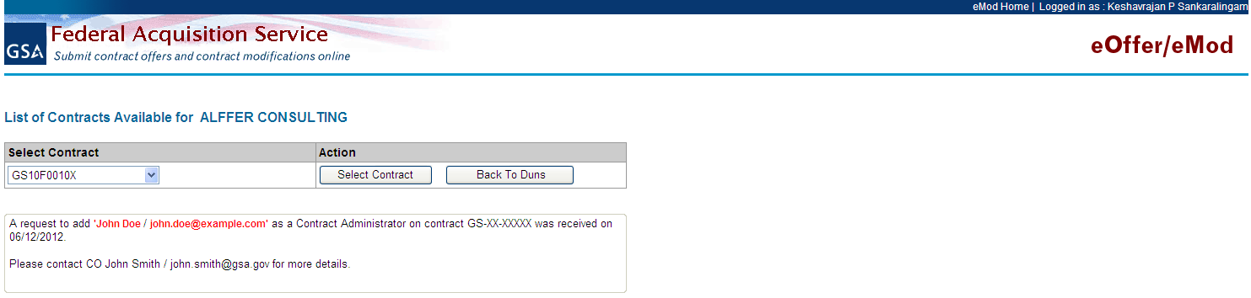

Requestor trying to select the contract (before 7 days)
When the user logs into eMod and selects the contract, for which
- User is not part of contract.
- Request for adding the user had already been initiated.
- The request initiation happened less than or equal to 7 days from current system date.
