eOffer/eMod FAS ID User Guide

Multi-Factor Authentication

Trademark Acknowledgement
All trademarks, registered trademarks, or service marks belong to their respective holders. Use of a term in this document should not be regarded as affecting the validity of any trademark or service mark. Any information or technology described herein that is the intellectual property of the trademark’s holder may not be duplicated, disseminated, or used without the specific permission of the property owner. The authors disclaim any proprietary interest in trademarks and trade names other than their own trademarks and trade names.

Table of Content

1 FAS ID Registration Steps 5
2 Multi-Factor Authentication Activation Steps 10
Email Authentication 13
SMS and Voice Authentication 15
Google Authenticator 17

3 Multi-Factor Authentication Login Steps 20
4 Cancel Login 23
5 Multi-Factor Authentication Account Forgot/Reset Password Steps 24
6 Sign up for eOffer/eMod 30
7 Abbreviations, Acronyms, and Definitions 35

Starting March 8, 2021, contractors must use FAS ID to access eOffer/eMod. GSA eOffer/eMod users without a FAS ID are required to register. Please review the groups below to determine your current status.

Group 1: Registration Required
Registration instructions begin on the next page (page 5)

Offerors/contractors that have not already registered for a FAS ID for another GSA application (FAS Sales Reporting Portal (SRP), GSA Advantage Purchase Order Portal, GSA Vendor Portal, the Mass Mod Portal, eBuy, etc.).

Note for New Offerors: please ensure that you are listed in the System for Award Management (SAM) as one of the following points of contact:
  - Government Business POC
  - Electronic Business POC
  - Government Business Alternate POC
  - Electronic Business Alternate POC
  - Past Performance POC
  - Past Performance Alternate POC

Note for Current Contractors: please ensure that you are listed as an Authorized Negotiator on the contract (with or without signing authority).

Group 2: Registration NOT Required
Login instructions begin on page 20

Offerors/contractors that are current eOffer/eMod users and use FAS ID for another application (FAS Sales Reporting Portal (SRP), GSA Advantage Purchase Order Portal, GSA Vendor Portal, the Mass Mod Portal, and eBuy). Your account will be validated based on you being an Authorized Negotiator on the contract. You do not need to register.

1 FAS ID Registration Steps
Step 1: Navigate to the eOffer/eMod home page at https://eoffer.gsa.gov/ and click on Register Account to complete your one-time registration process.

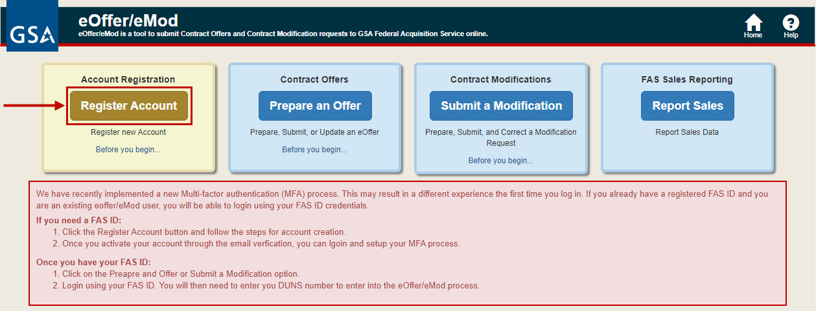
Step 2: Enter your email address, first name, last name, and DUNS number, then click Submit.

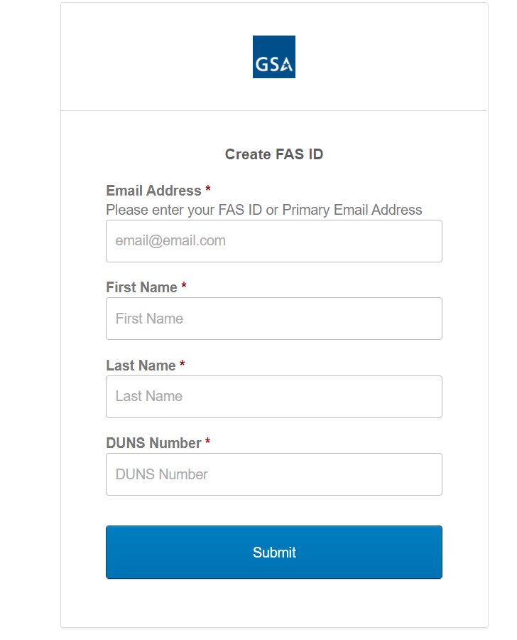

Step 3: If your credentials are successfully verified, you will be redirected to a success page with details of the next steps to activate your Multi-Factor Authentication (MFA) account.

An email will be sent to the email address you provided for Registration with a link to complete Activation of your account. Please continue to Section 2 on page 11.

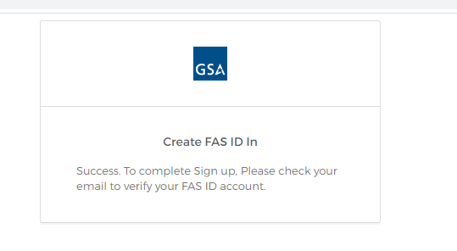

Error Messages
NOTE: The system will display an error message in the following situations:
  - Your name & email are not listed in at least one of the point of contact fields in SAM.gov:
Government Business POC, Electronic Business POC, Government Business Alternate POC, Electronic Business Alternate POC, Past Performance POC, Past Performance Alternate POC
- Please coordinate with your SAM.gov administrator to update the points of contact in SAM.gov with your information.
  - Your name & email are not listed in your GSA contract as an Authorized Negotiator.
- Please coordinate with the Authorized Negotiator on your GSA contract to update the contract with your contact information. You will need to be added as an Authorized Negotiator to access eOffer/eMod.
  - DUNS number is incorrect/not valid.
- Your DUNS number can be searched on SAM.gov.

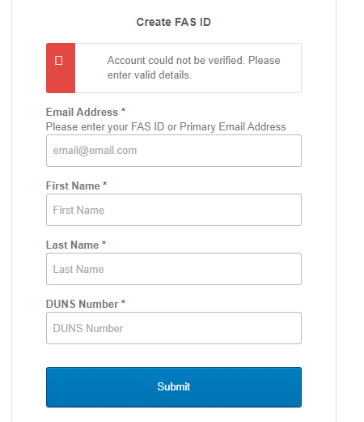

  - Your account is already registered. Please return to the eOffer/eMod home page and click login instead.

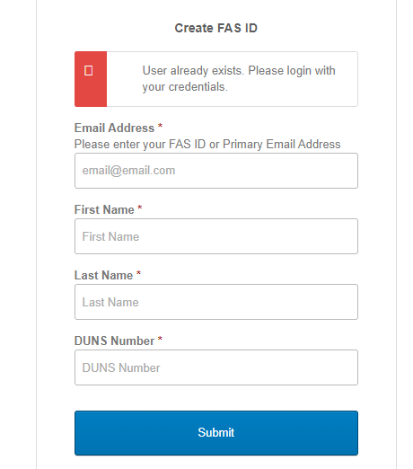

2 Multi-Factor Authentication Activation Steps

Step 1: Proceed to your email inbox and select the Activate Account button from the email you received.

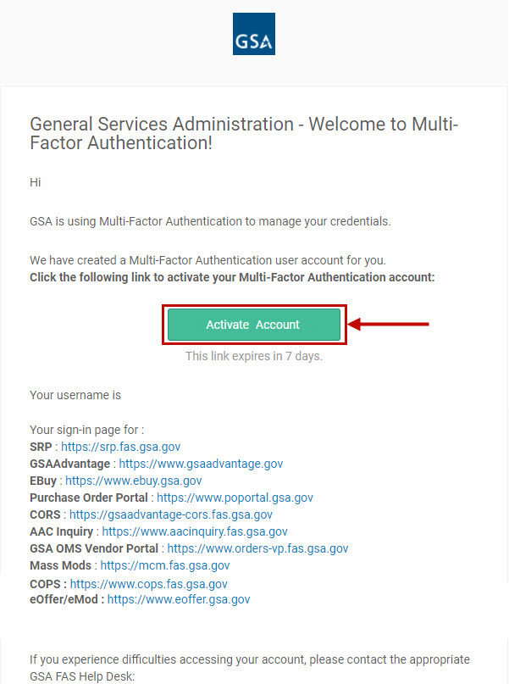
Step 2: Enter and confirm your password
Step 3: Select and answer a security question
Step 4: Select a security Image

Step 5: Click on Create My Account

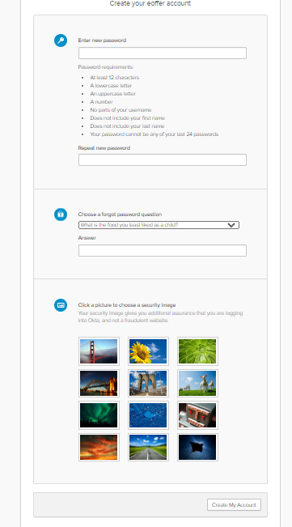
Step 6: Setup your Multi-Factor Authentication method. This will be the method in which you will receive your one-time code each time you log in to the system. Please review the choices carefully and click Setup for your preferred MFA method.
Please note: If you choose the Google Authenticator option, please ensure that you have the mobile app for Google Authenticator installed on your mobile device. This option will ask you to scan a QR code to add the account to your Google Authenticator app so you can complete activation and receive your MFA code.

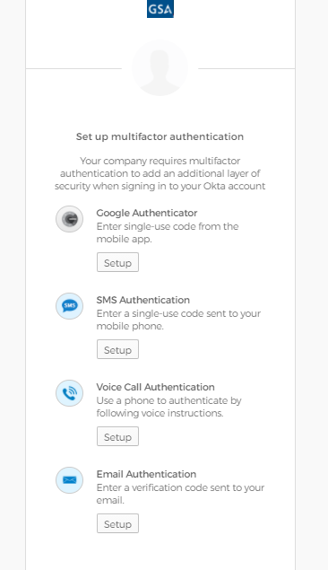

Email Authentication Multi-Factor Method
Step 7: Click Send me the code to receive the One Time Passcode (OTP).

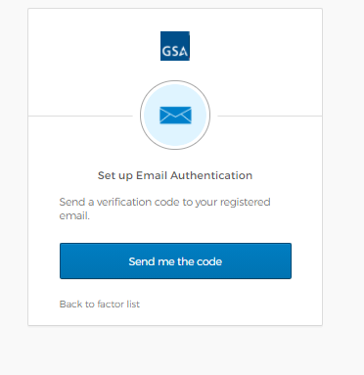
Step 8: Once you select the Send me the Code button, you will receive an email with the One Time Passcode (OTP).
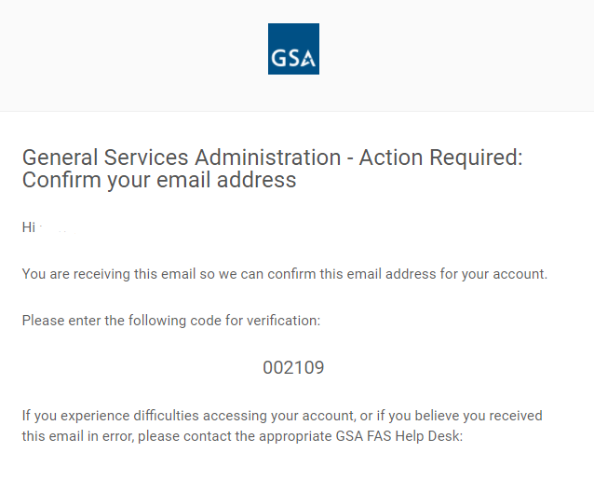
Step 9: Enter the One Time Passcode (OTP) and click Finish.
NOTE: If at any time you would like to add or remove your current method of Authentication (from email to text, etc.), please contact the help desk at 1-866-472-9114.

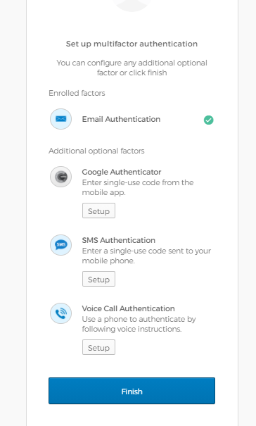

Step 10: You will successfully be logged in to your FAS ID Account and able to view the GSA applications associated with your FAS ID account. Click on the eOffer/eMod box to access the system.

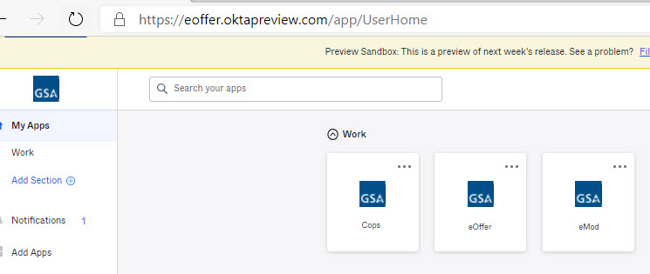

SMS and Voice Authentication

Step 7: If you choose to utilize either SMS or Voice Authentication, you will be prompted to enter in your 10-digit phone number, including the area code. Once you do, click Send me the Code. If you choose SMS, you will receive a code in the form of a text message, and if you choose Voice, you will receive a phone call with the code spoken to you. Both will be from random phone numbers that you cannot reply or call back.

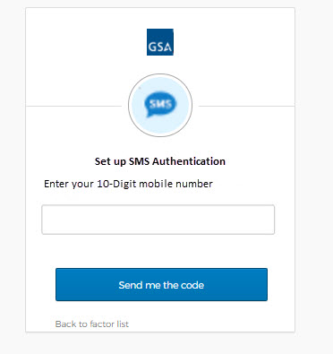

Step 8: On the next screen, enter in the code that was texted or given to you over the phone, and click Verify.

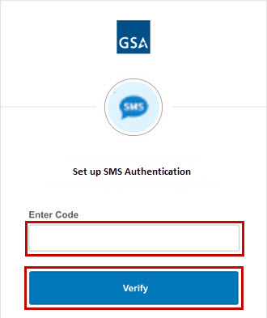

Step 9: Once successful, you will be redirected to your dashboard where you can view all of the applications that are linked to your new MFA account. Click on the eOffer/eMod box to access the system.

Google Authenticator

Step 7: When you get to the Setup Google Authenticator page, simply select the radio button for the device type you currently have for your phone. Make sure you have the Google Authenticator app on your phone already, or you can download the Google Authenticator app from your phone’s app store. Once you have the app, click Next.

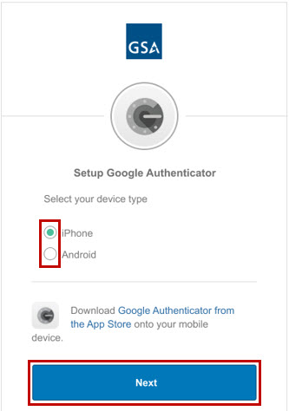

Step 8: On the next page, you will see a QR Code. Open the Google Authenticator app on your phone and scan the QR Code by pressing the + button. You will then receive a 6 digit code that updates automatically every 30 seconds. You can determine how much time is remaining by the small circle next to the code. Once your code is active, you can click Next.

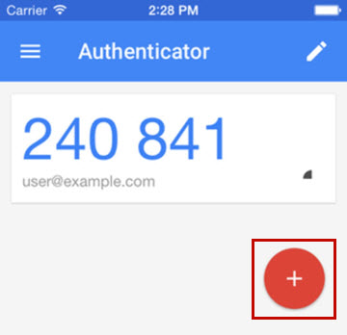

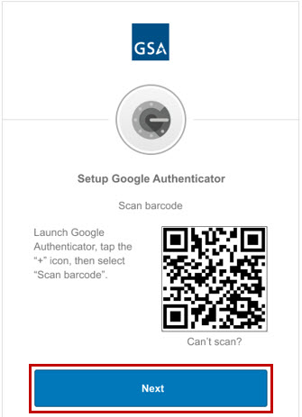

Step 9: Enter in the current 6 digit code from your phone into the box on the next page, and click Verify.

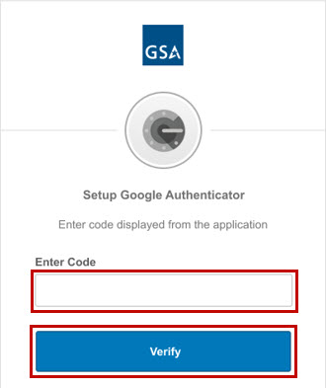

Step 10: If successful, you will be redirected to your dashboard where you can view all of the applications that are linked to your new MFA account. Click on the eOffer/eMod box to access the system.

3 Multi-Factor Authentication Login Steps
Step 1: After successfully completing the Multi-Factor Authentication registration process or if you are a member of Group 2, all future access will be performed by accessing Prepare an Offer or Submit a Modification from the eOffer/eMod home page at https://eoffer.gsa.gov/.
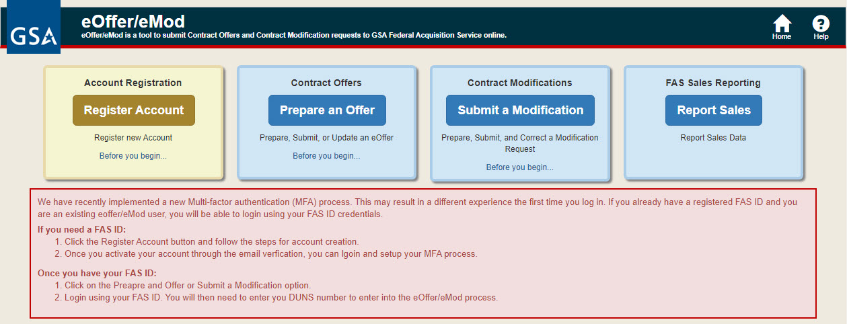

Step 2: Enter your FAS ID email and password, and then click Next.
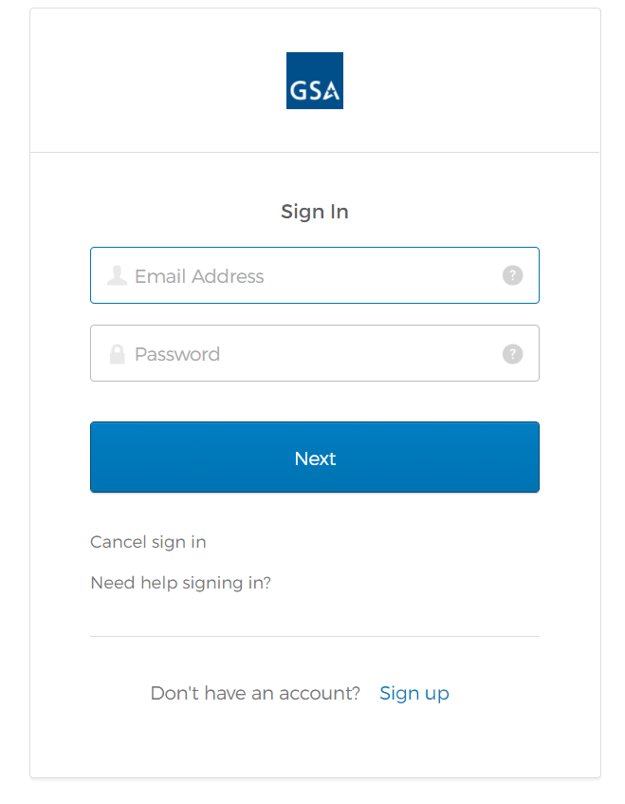

Step 3: Validate your code from your MFA Authenticator to access eOffer/eMod. Alternatively, if you chose another method of MFA, enter in the required information (e.g. code from SMS text message, or the code from your email).

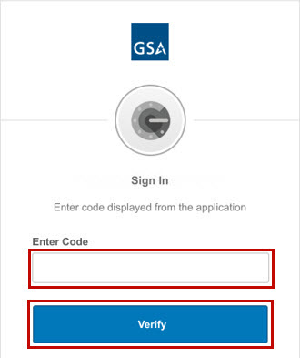

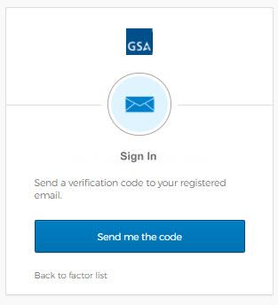

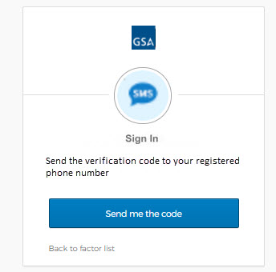
Step 4: You will successfully access the eOffer/eMod system. Please enter your DUNs number to continue your work in the system.

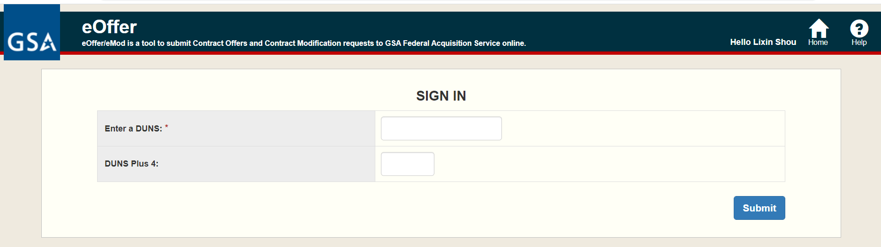

4 Cancel Login

The Cancel sign in link will cancel login and return you to the eOffer/eMod home page.

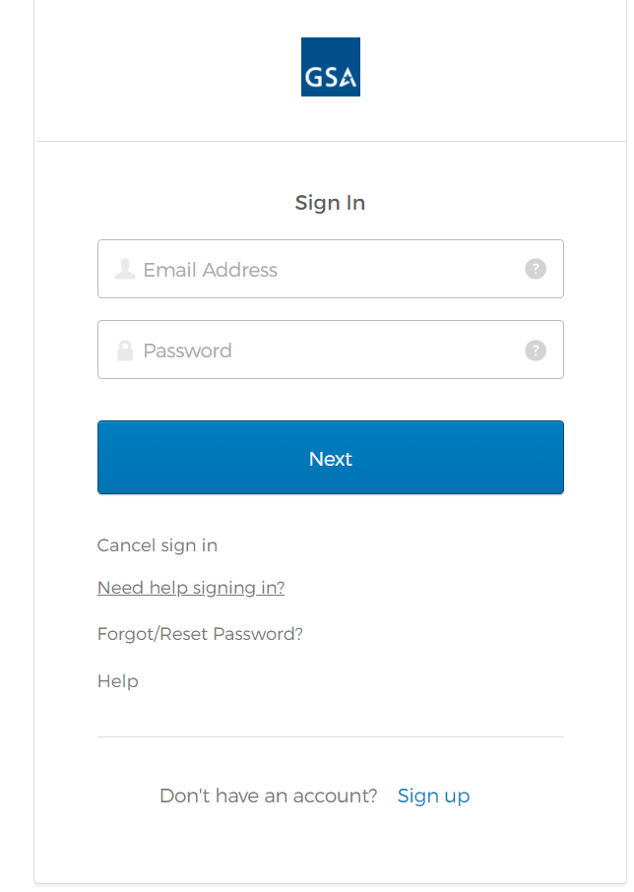

5 Multi-Factor Authentication Account Forgot/Reset Password Steps

Step 1: Click on Need help signing in? and select Forgot/Reset Password?

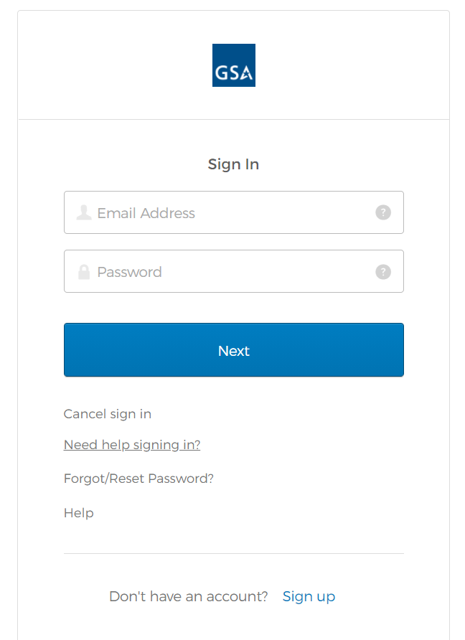
Step 2: Enter your email and click Reset via Email.
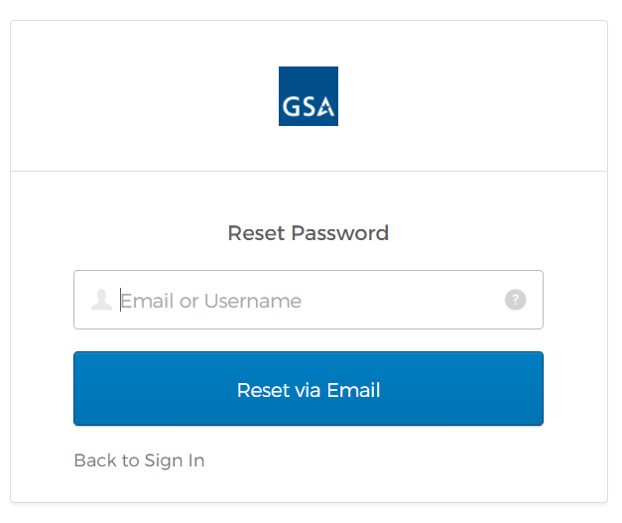
Step 3: The confirmation page will show up
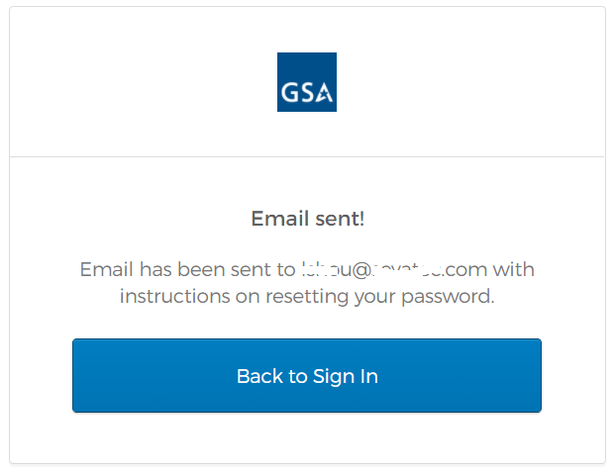

Step 4: Access the Reset Password link from the reset password email received from MFA-No-Reply+noreply@gsa.gov. Please check your Spam or Junk inbox folders in case you do not see the email in your regular email inbox.
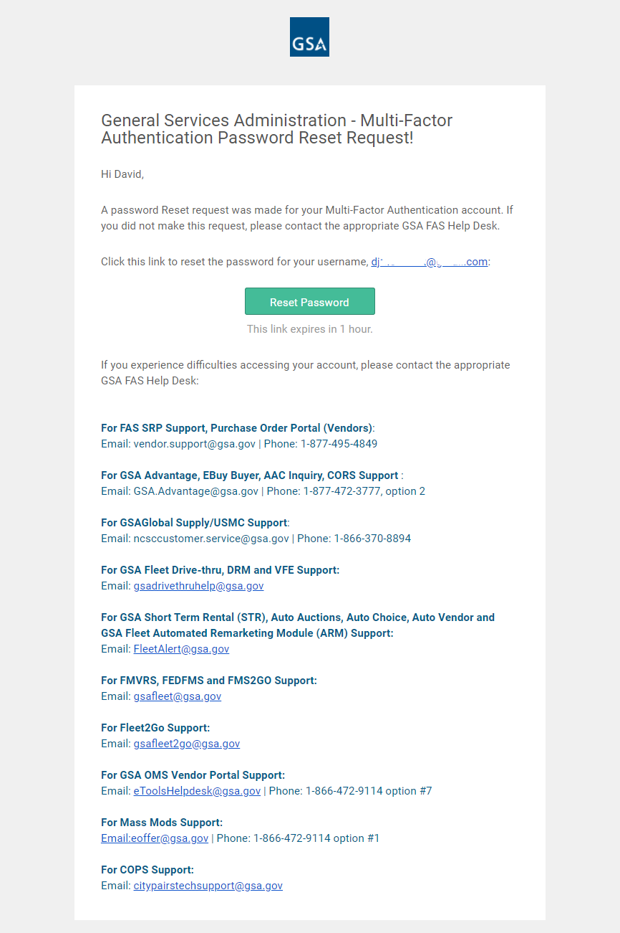
Step 5: Answer your security question and click Reset Password. If you cannot remember the answer to your security question, please reach out to the eOffer/eMod Help Desk:
Email: eOffer@gsa.gov
Telephone: (866) 472-9114

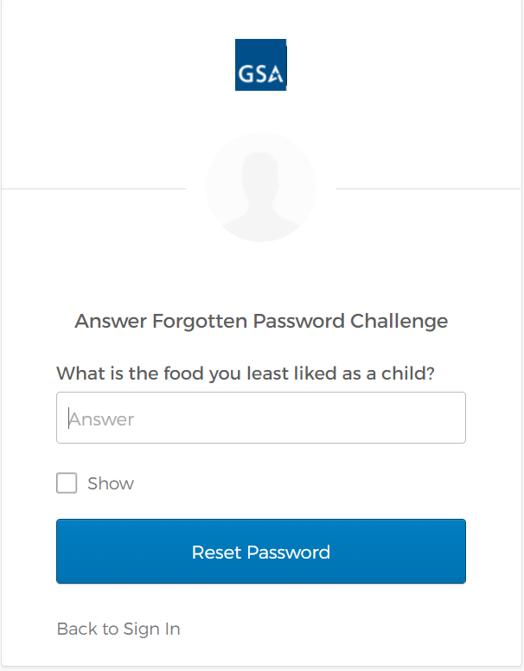
Step 6: Enter and confirm your new password and click Reset Password

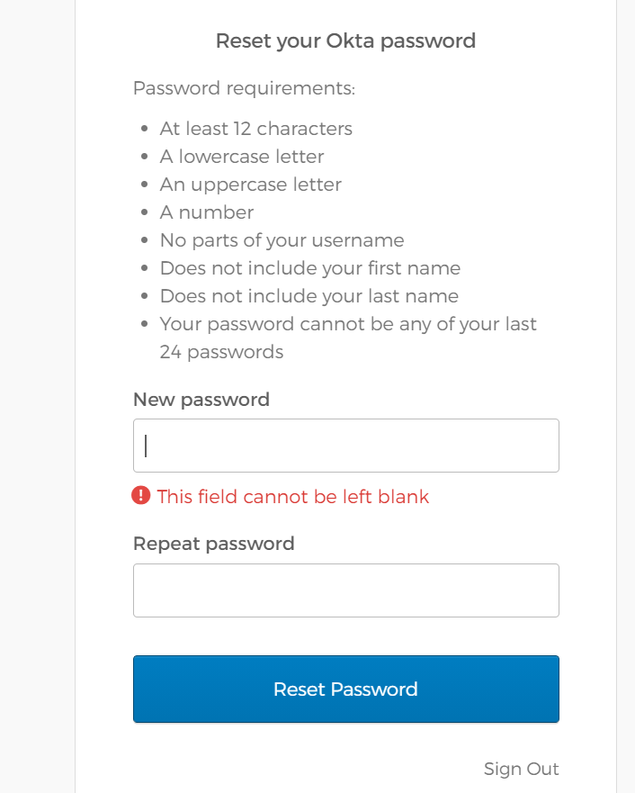

Step 7: You will successfully log in to the FAS ID dashboard and see a list of applications in your dashboard.

6 Sign up for eOffer/eMod

Step 1: The Sign up link at the bottom will take the user to the registration page at any time during the sign in process. If you are unsure if you have registered for your FAS ID, use this process to quickly verify that your account is active.

Step 2: This is the same registration page in Section 1 “Multi-Factor Authentication Registration Steps”.

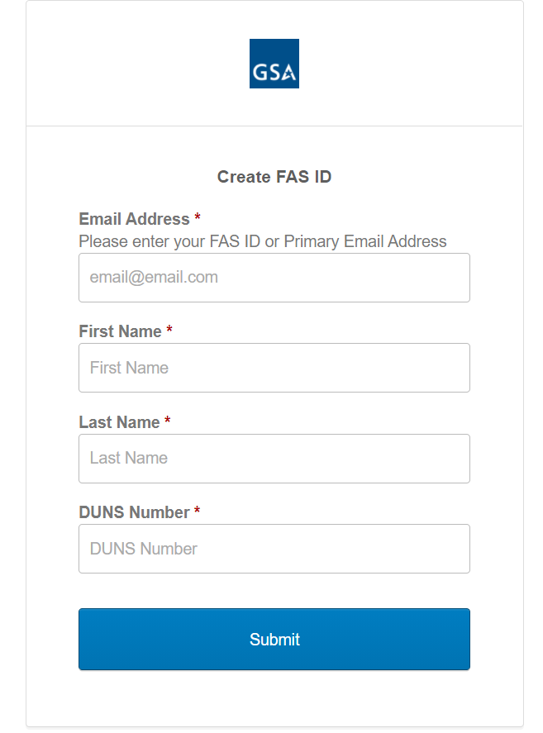

7 Abbreviations, Acronyms, and Definitions

The following abbreviations, acronyms, and definitions are used within this document and throughout GSA.
Abbreviation | Definition
GSA | General Services Administration
OTP | One Time Passcode
MFA | Multi-Factor Authentication

